Project Design Phase-II
Data Flow Diagram & User Stories

Date | 19 February 2026
Team ID | LTVIP2026TMIDS89796
Project Name | Heritage Treasures: An In-Depth Analysis of UNESCO World Heritage Sites in Tableau
Maximum Marks | 4 Marks

Data Flow Diagrams:
A Data Flow Diagram (DFD) visually represents how data moves through the system. For the project UNESCO World Heritage Sites Analytics Using Tableau and Flask, the DFD includes the following components:
- External Entities: User, Researcher, Student, Administrator
- Processes: Data Collection, Tableau Visualization Development, Dashboard Analysis, Web Integration using Flask, Interactive Reporting
- Data Stores: UNESCO Heritage Dataset (Excel), Tableau Dashboards, Embedded Web Pages
Flow Summary:
- UNESCO heritage dataset is collected → Data prepared and loaded into Tableau.
- Tableau processes data → Dashboards and visual analytics are created.
- Dashboards are published → Embed links generated for web integration.
- Flask application loads dashboards → Users interact with visualizations and analyze insights.
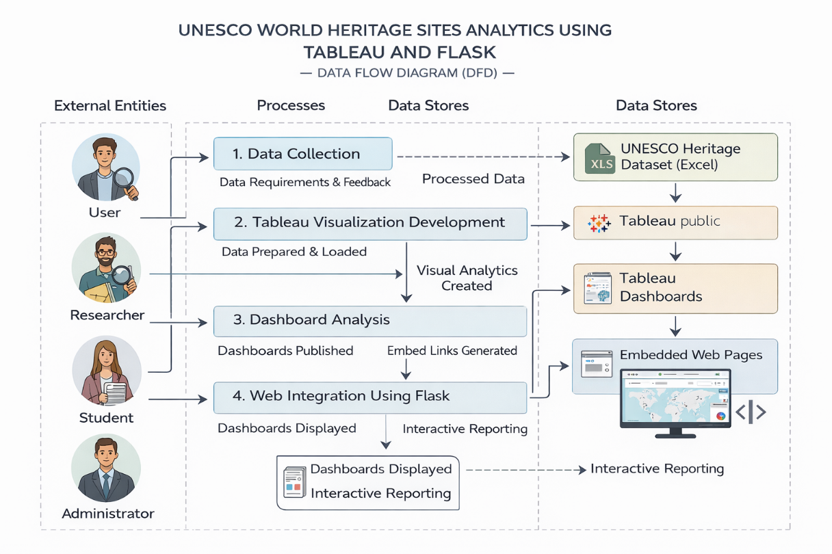
Fig: Data Flow Diagram
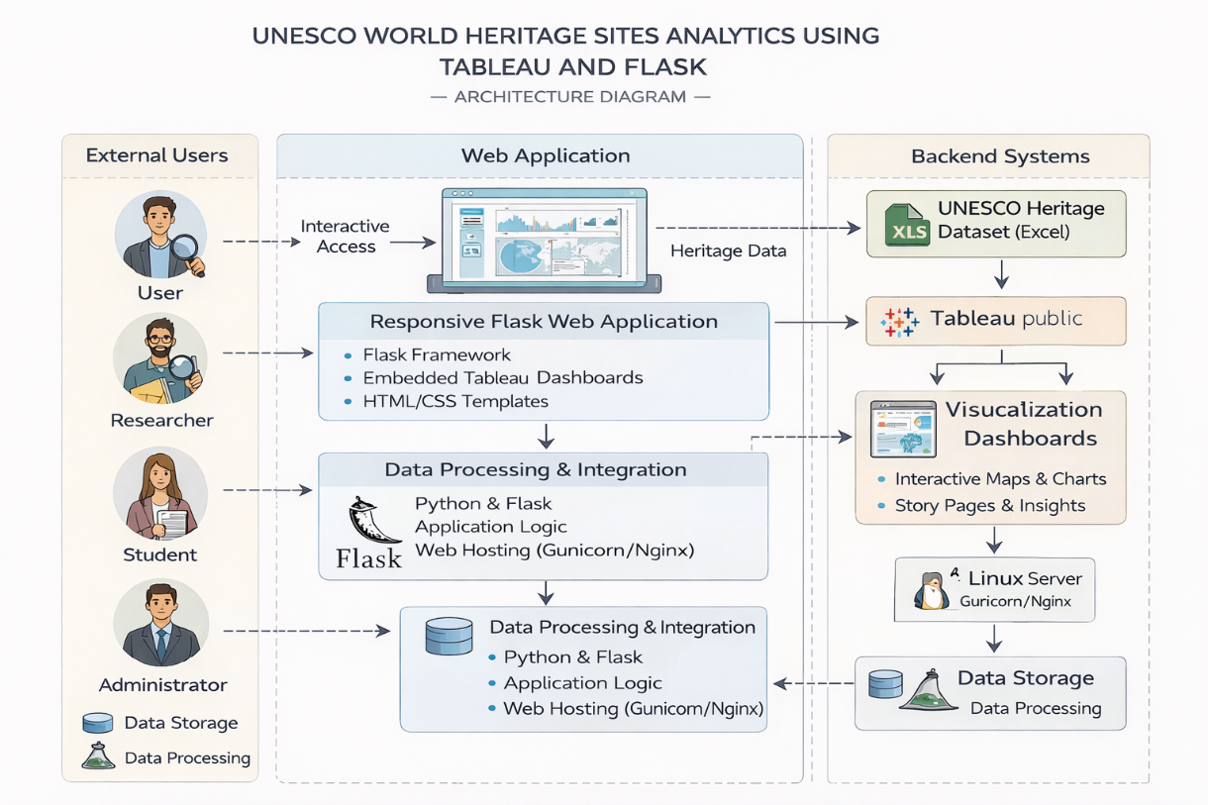
Fig: Architecture
User Stories:
User Type | Functional Requirement (Epic) | User Story Number | User Story / Task | Acceptance Criteria | Priority | Release
User | Dashboard Access | USN-1 | As a user, I can view UNESCO heritage dashboards through the website | Dashboards load correctly inside web page | High | Sprint-1
User | Data Visualization | USN-2 | As a user, I can explore maps, charts, and analytics visually | Interactive charts respond to user actions | High | Sprint-1
Researcher | Data Analysis | USN-3 | As a researcher, I can analyze heritage site trends by region and category | Filters and insights display accurate data | Medium | Sprint-2
Admin | Tableau Integration | USN-4 | As an admin, I can embed Tableau dashboards into Flask pages | Embedded dashboards display without errors | High | Sprint-2
User | Story Navigation | USN-5 | As a user, I can navigate between dashboards and story sections | Navigation buttons work smoothly | Medium | Sprint-3
Admin | Web Application Management | USN-6 | As an admin, I can run and manage the Flask application locally | Flask server runs and loads templates | Medium | Sprint-3
User | Interactive Reporting | USN-7 | As a user, I can interact with visual reports to gain insights | Hover, zoom, and filters work properly | Medium | Sprint-4

